Optional File 50_region_hvytrk_powertrain_prop.csv
June 2, 2026
Definition of the Input File
VisionEval (https://visioneval.github.io/docs/model-inputs.html) explains that this input file is optional. It is only needed if the user wants to modify the powertrain proportion of heavy-duty trucks. This file contains two attributes:
- HvyTrkPropIcev: Proportion of heavy truck travel powered by internal combustion engine powertrains
- HvyTrkPropHev: Proportion of heavy truck travel powered by hybrid electric powertrains
- HvyTrkPropBev: Proportion of heavy truck travel powered by battery electric powertrains
For example, the data below suggest that the proportion of heavy truck travel powered by internal combustion engine powertrains in Virginia in 2024 is 0.99892, while the proportion powered by hybrid electric powertrains is 0.00017. The values in each row must sum to 1; otherwise, VisionEval may crash. (When saving the CSV file, Excel may automatically truncate values after the ninth decimal place. Therefore, if the user alters these, the row totals should be checked to ensure that the sum remains 1.)
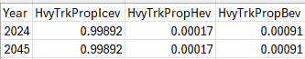
Possible Scenario
Changes to this file would likely be useful for analyzing the impacts of changes in heavy truck powertrain composition, such as differences in emissions, energy consumption, and operating costs. The document Task 7.2 Simplified Scenario Development guide available at A Playbook for Simplified Approaches for Creating Scenarios in VisionEval explains that this file modifies the mix of heavy-duty truck powertrains within the model region by specifying the share of total VMT associated with each powertrain type for a given year, rather than assigning specific vehicles.
Method Used for Virginia
Although the extrapolation method below gives 2024 and 2045 values, the research team believes that the short-term extrapolation (to 2024) is reliable but the 2045 extrapolation is speculative. Thus, the 2045 values are set to be equal to the 2024 values.
Several steps were used to develop these data for the 2024 and 2045.
- Source: Motor Vehicle Registration Data by Energy Source: 2016-Present, Virginia Open Data Portal
  - URL: https://data.virginia.gov/dataset/motor-vehicle-registration-data-by-energy-source-2016-present?utm_source=chatgpt.com
  - Location: Organizations–U.S. Department of Transportation–Motor Vehicle Registration Data by Energy Source: 2016-Present
  - Search Keyword: Energy Source
  - Related Sheet: Not Applicable

- Year that the Data Reflect: 2024 (The 2024 value was projected using data from 2021 to 2023.) 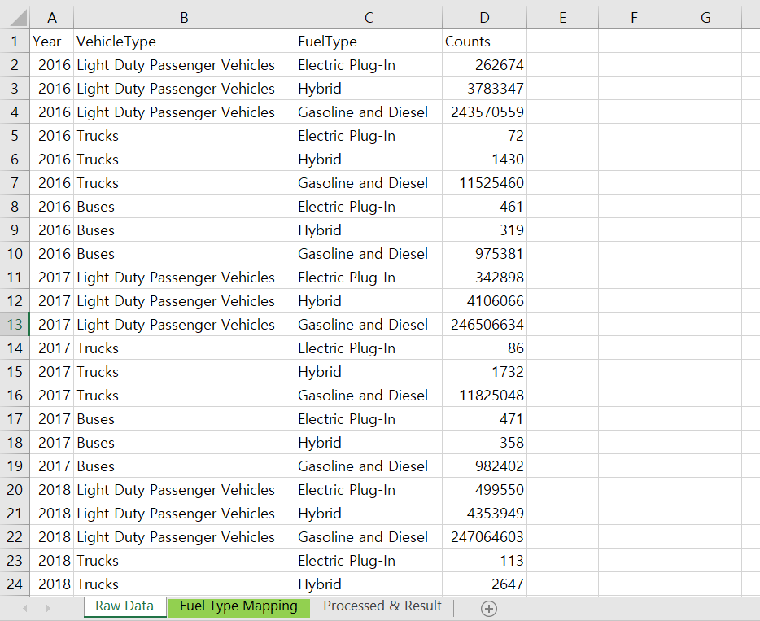

- How the Data Were Processed: All processing steps were almost the same as those used for the “region_comsvc_powertrain_prop” input.
  - Vehicle Type Mapping: The data source was the FHWA Highway Statistics VM-1. Although the FHWA vehicle classification system includes thirteen categories (https://www.fhwa.dot.gov/policyinformation/tmguide/tmg_2013/vehicle-types.cfm), the dataset provides only three broad types: light-duty passenger vehicles, trucks, and buses. Therefore, the vehicle types were mapped as follows.
Vehicle Types (FHWA) | Category (Motor Vehicle Registration Data)
Class 2-3 | Light-Duty Passenger Vehicles
Class 4 | Buses
Class 5 and above | Trucks

  - Heavy Trucks Assumption: Heavy trucks, as referenced in the input variables, are assumed to correspond to FHWA Class 5 and above.

  - Fuel Type Mapping
Fuel Type (NTD) | Category
Gasoline and Diesel | ICEV
Hybrid | HEV
Electric Plug-In | BEV

  - Base Year and Target Year Values Projection: At first, both the 2024 base year and the 2045 target year values were projected using the compound annual growth rate (CAGR) calculated from 2021 to 2023 data. However, the number of electric vehicles was significantly overestimated due to their high initial adoption rate. 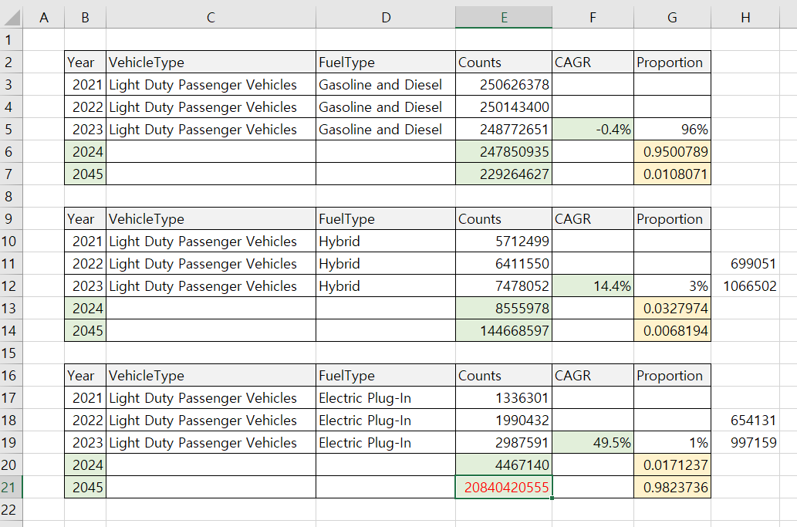
Therefore, the total number of trucks was projected by year first, and then the number of gasoline and diesel vehicles was estimated based on the CAGR.
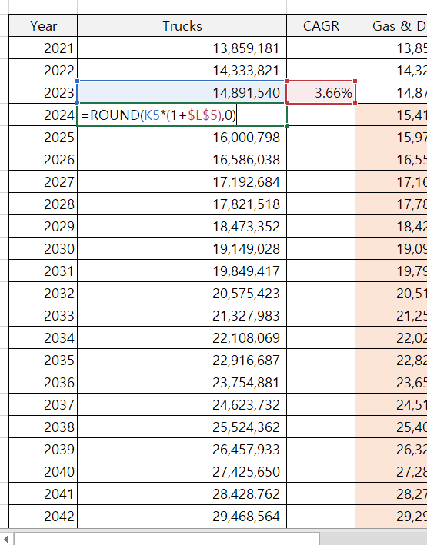 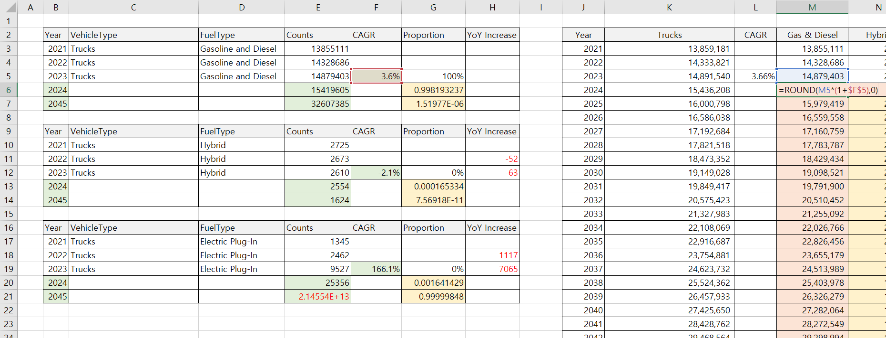
Given that the CAGR of hybrid vehicles is moderate and appears reasonable, the number of hybrid vehicles was estimated using the CAGR. Then, the number of electric vehicles by year was derived by subtracting the number of gasoline/diesel and hybrid vehicles from the total number of trucks.
Finally, the proportion of each vehicle type was calculated based on the estimated values.
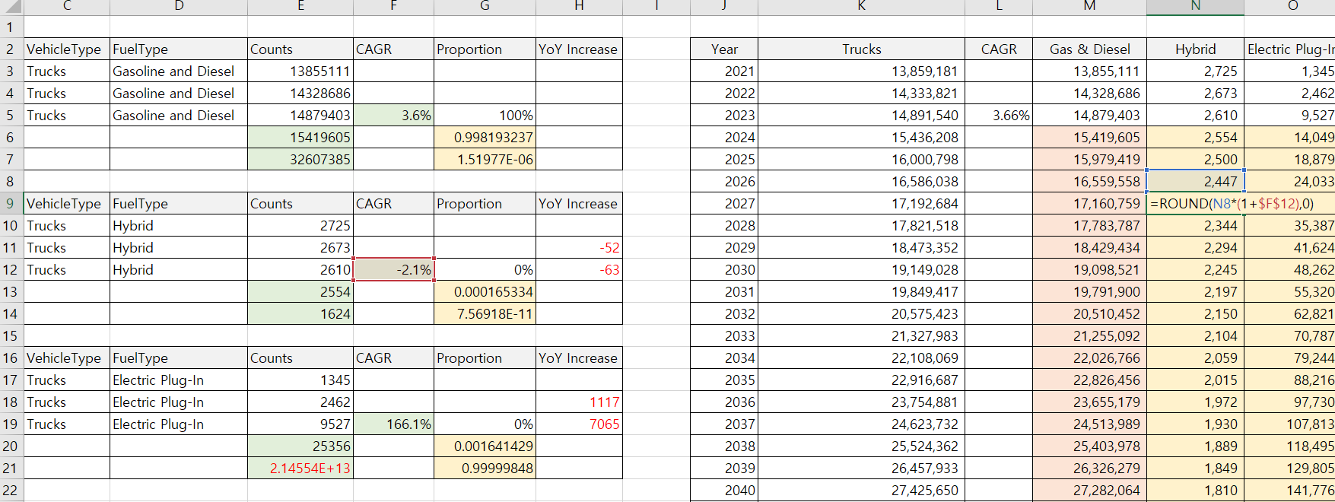
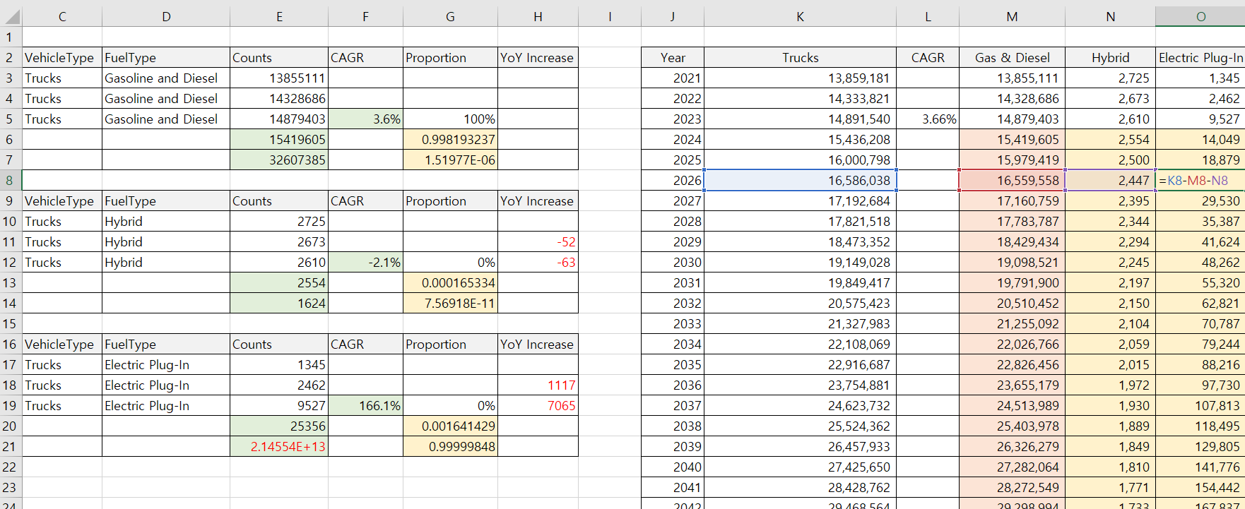
  - Final Result. Note that in the CSV file, the year 2045 values were set equal to the year 2024 values, although this assumption may be adjusted by the user.
